FACTSALES PERFORMANCE
DASHBOARD REPORT
Project Report Submitted By
Name: Kaviya D

Introduction
This project presents an interactive FACTSALES Performance Dashboard developed in Microsoft Power BI. The dashboard converts sales transaction information into visual summaries that can be explored through date, discount and geography filters. It combines sales, profit and quantity indicators with channel, payment method, order priority, product and shipping-date analysis.
The dashboard is designed to make sales information easier to interpret at a glance. Instead of depending only on raw records, the report brings together KPI cards, column charts, a time-series visual, a doughnut chart, a comparison visual and a scatter plot so that different aspects of sales performance can be examined together.

Objectives
- Analyze total sales, total profit and quantity using an interactive Power BI dashboard.
- Compare sales amounts across different sales channels.
- Observe the movement of sales amount across shipping dates.
- Examine the distribution of orders by payment method.
- Explore the relationship between order priority and profit-related values.
- Compare profit values across different product keys.
- Use date, discount and geography filters to interact with the dashboard.

Dashboard Data Description
The visible dashboard identifies the main analytical fields through its visuals and filters. The report uses SalesAmount, Profit and Quantity for performance indicators, while Channel, ShipDateKey, PaymentMethod, OrderPriority, ProductKey, OrderDateKey, Discount and GeographyKey provide different dimensions for analysis.
Field / Dimension | Use in Dashboard
SalesAmount | Main sales value used in channel and shipping-date analysis.
Profit | Used for the total profit KPI and profit-related visual analysis.
Quantity | Displayed through the quantity KPI.
Channel | Compares sales across Partner, Retail, Online and Phone.
ShipDateKey | Shows sales amount movement over shipping dates.
PaymentMethod | Shows the distribution of payment methods.
OrderPriority | Used in the order-priority and profit comparison visual.
ProductKey | Used to compare profit values across products.
OrderDateKey | Provides date filtering for the dashboard.
Discount | Provides selectable discount values for filtering.
GeographyKey | Provides a geography-based filter.

Data Preparation
The dashboard is organized around sales transaction fields and their aggregated values. The numerical fields SalesAmount, Profit and Quantity are presented as performance indicators, while categorical and date-related fields are used to divide and filter the data.
- SalesAmount, Profit and Quantity are used as numerical performance fields.
- Channel, PaymentMethod and OrderPriority provide categorical comparisons.
- ShipDateKey and OrderDateKey provide date-based analysis and filtering.
- ProductKey is used for product-level profit comparison.
- Discount and GeographyKey are available as interactive filters.
- The dashboard layout groups summary KPIs, analytical visuals and slicers so that users can explore the data interactively.

Measures / KPI Values Displayed
The dashboard visibly presents three main KPI cards. These values provide a quick summary before the user moves to the detailed visuals. The exact formulas are not visible in the supplied screenshot, so this report describes the displayed measures by their dashboard labels rather than assuming formula definitions.
Dashboard KPI | Displayed Value | Purpose
Total Profit | 25.12M | Summarizes the profit value displayed in the report.
Total Sales | 70.64M | Summarizes the sales value displayed in the report.
Count of Quantity | 100K | Shows the quantity count displayed in the report.

Dashboard Filters
Filter | Function
OrderDateKey | Allows the user to select a date range; the visible range is 1/1/2018 to 12/31/2024.
Discount | Provides selectable discount values including 0.00, 0.05, 0.10, 0.15 and 0.20.
GeographyKey | Provides a geography selection; the visible default is All.

Dashboard Overview
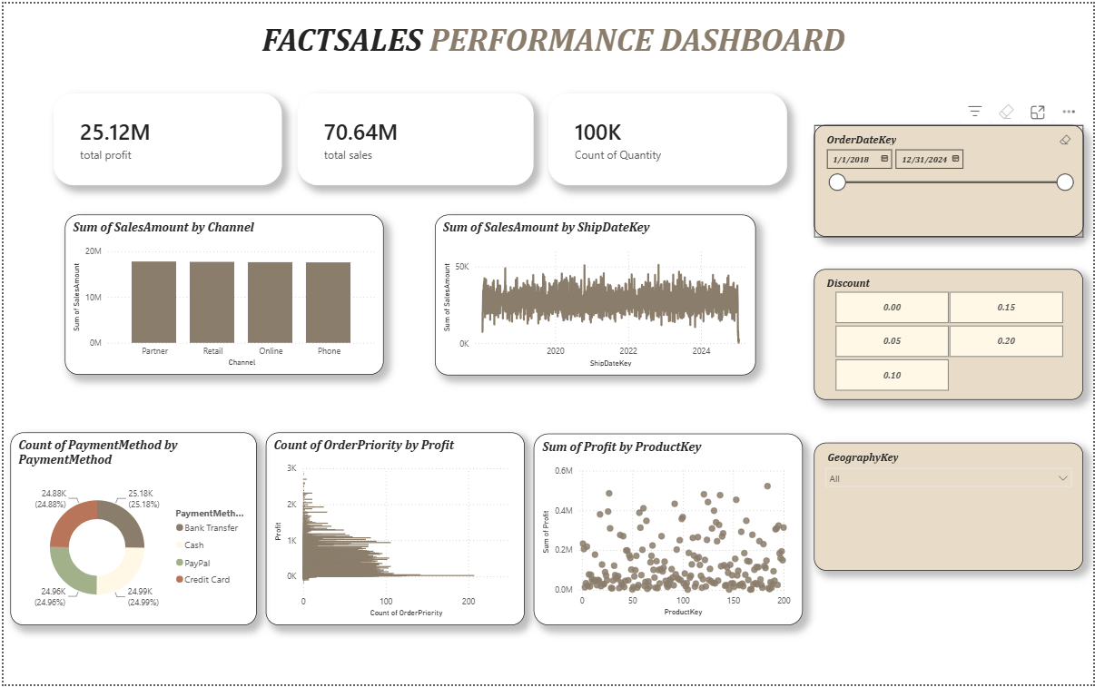

The main dashboard combines three KPI cards with six analytical areas. At the top, Total Profit is 25.12M, Total Sales is 70.64M and Count of Quantity is 100K. The right side contains OrderDateKey, Discount and GeographyKey filters. The remaining visuals analyze channel, shipping date, payment method, order priority and product profit.

Main Dashboard Components
- KPI cards provide an immediate summary of profit, sales and quantity.
- The Channel column chart compares sales amount across Partner, Retail, Online and Phone.
- The ShipDateKey line visual shows sales amount across the displayed date period.
- The PaymentMethod doughnut chart compares Bank Transfer, Cash, PayPal and Credit Card.
- The OrderPriority visual compares order-priority counts with profit-related values.
- The ProductKey scatter plot shows the distribution of profit values across product keys.
- OrderDateKey, Discount and GeographyKey slicers allow interactive filtering.

Sales Amount by Channel
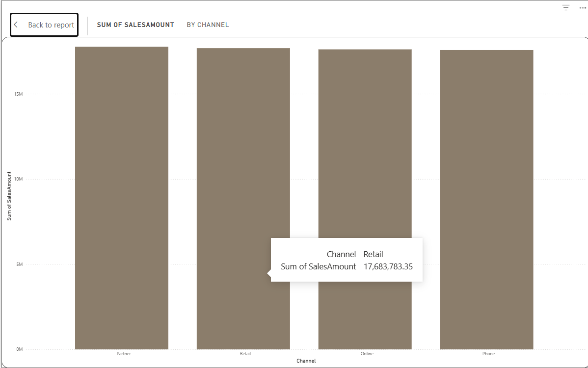

The column chart titled 'Sum of SalesAmount by Channel' compares the total sales amount generated through Partner, Retail, Online and Phone channels. The four bars are visually close in height, indicating that the displayed sales amounts across the channels are relatively similar.

Key Findings
- Partner, Retail, Online and Phone all contribute substantial sales amounts.
- The bars are close to one another, so no large visual difference is shown between the four channels.
- The chart provides a direct channel-level comparison of sales amount.
- The visual can be used together with the available filters to examine channel performance under different selections.

Sales Amount by Ship Date Key
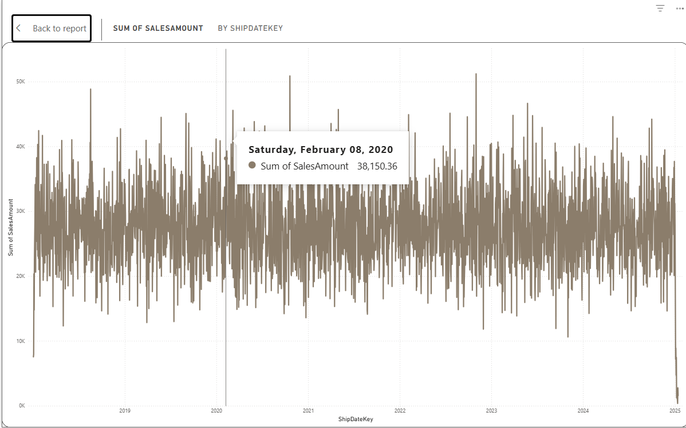

The line chart titled 'Sum of SalesAmount by ShipDateKey' tracks sales amount across the shipping-date period. The visual contains frequent movements around a broad sales range and makes changes in sales amount over time visible.

Key Findings
- Sales amount fluctuates frequently across the displayed shipping dates.
- The visual covers a period that includes the years 2020, 2022 and 2024 on the visible axis.
- The sales values generally remain within a similar broad range, with repeated upward and downward movements.
- The chart is useful for identifying periods with unusually high or low sales activity.
- The OrderDateKey filter can be used to focus the dashboard on a selected date range.

Payment Method Analysis
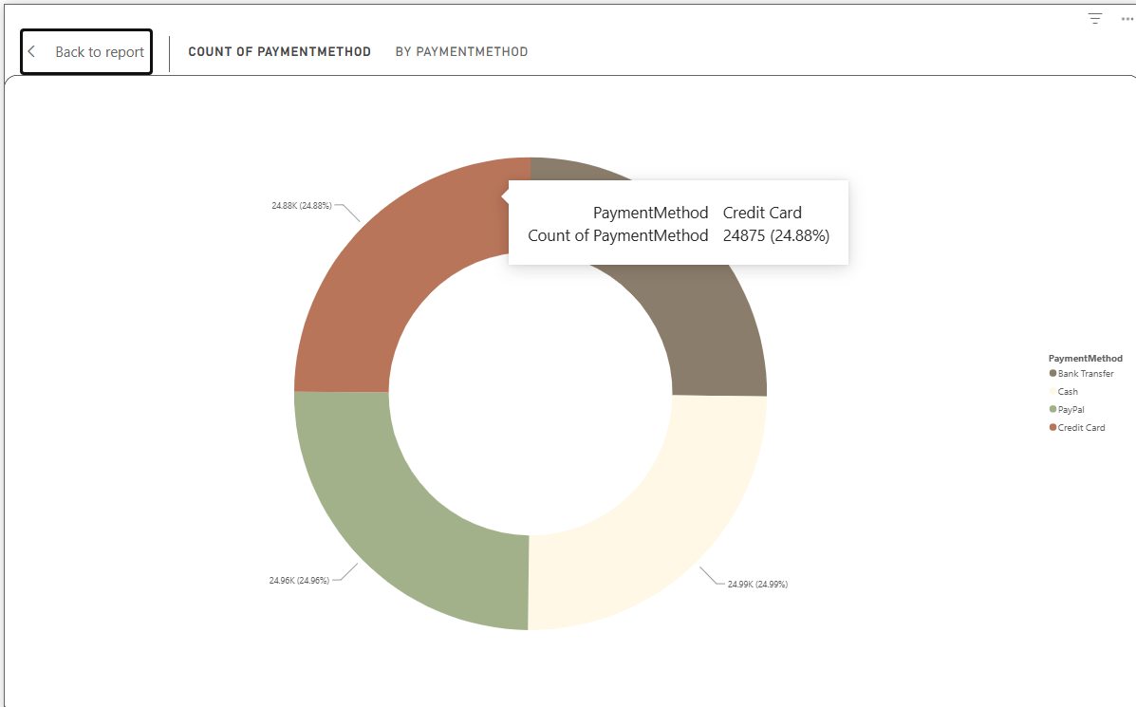

The doughnut chart titled 'Count of PaymentMethod by PaymentMethod' compares the distribution of four payment methods: Bank Transfer, Cash, PayPal and Credit Card. The labels show values close to one another, indicating a relatively balanced distribution in the displayed dashboard.

Key Findings
- Bank Transfer is displayed at approximately 25.18K (25.18%).
- Cash is displayed at approximately 24.99K (24.99%).
- PayPal is displayed at approximately 24.96K (24.96%).
- Credit Card is displayed at approximately 24.88K (24.88%).
- The four payment methods have similar shares, with each accounting for about one-quarter of the displayed count.

Order Priority and Profit Analysis
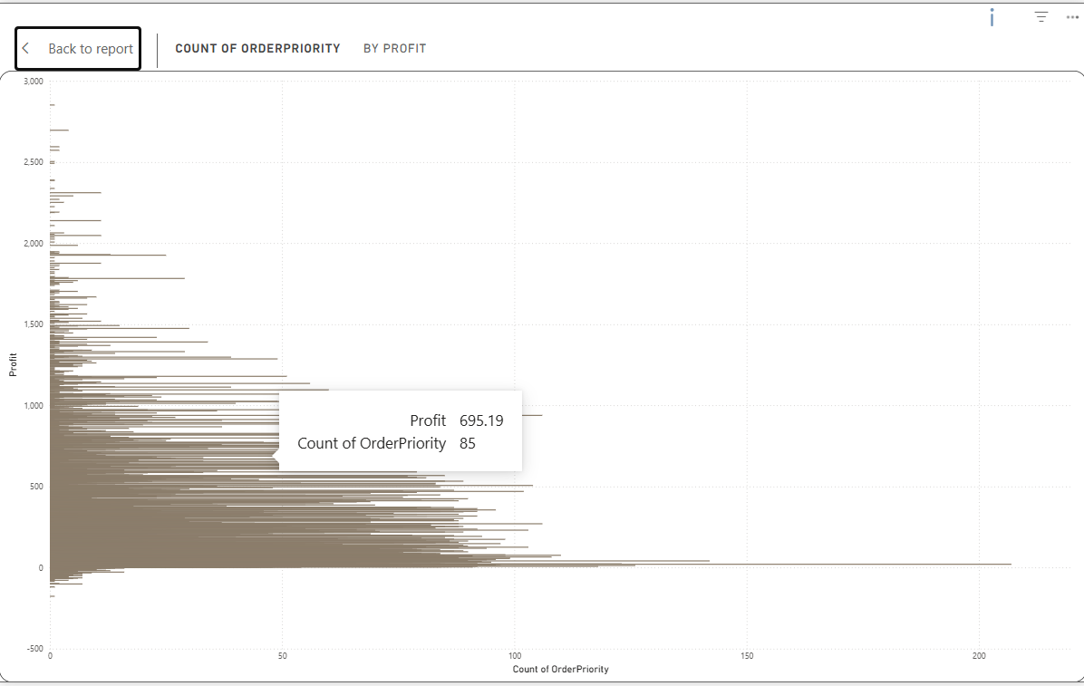

The visual titled 'Count of OrderPriority by Profit' presents order-priority categories against profit-related values. The horizontal display contains many records and allows the user to observe how the plotted values are distributed across the order-priority measure.
- The visual contains a wide spread of plotted values rather than a single concentrated level.
- The x-axis represents Count of OrderPriority, while the y-axis displays Profit values.
- The chart is useful for exploratory comparison of order priority and profit-related values.
- The screenshot does not provide enough information to establish a statistical relationship from this visual alone.

Profit by Product Key
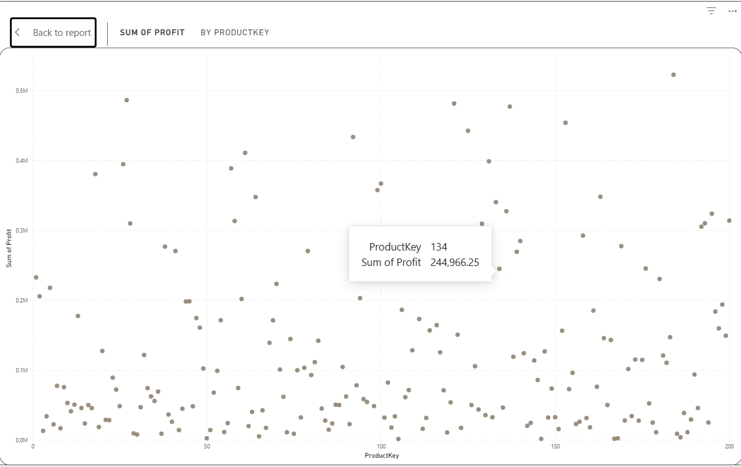
The scatter plot titled 'Sum of Profit by ProductKey' places ProductKey on the horizontal axis and Sum of Profit on the vertical axis. The points are distributed across product keys from approximately 0 to 200, with profit values extending from near zero to above 0.5M.
- Most points are concentrated in the lower profit range.
- Several product keys show higher profit values, including observations above 0.4M.
- The visual helps identify products with comparatively high profit values for further investigation.
- Because the plot is exploratory, additional calculations would be needed to establish any statistical relationship.

Interactive Features

OrderDateKey Filter
The OrderDateKey slicer provides a date-range selection for the dashboard. In the screenshot, the selected range runs from 1/1/2018 to 12/31/2024. Changing the range allows the displayed KPI cards and visuals to be viewed for a selected period.

Discount Filter
The Discount slicer provides selectable values of 0.00, 0.05, 0.10, 0.15 and 0.20. This allows the user to examine dashboard results under different discount selections.

GeographyKey Filter
The GeographyKey slicer is shown as a dropdown with the default selection 'All'. It provides a way to filter the dashboard according to geography-related records.

Interactive Exploration
Together, the three filters make the dashboard interactive rather than static. Users can change the date range, discount and geography selection and then observe the corresponding changes in the dashboard visuals.

Key Findings
Area | Finding
Overall scale | The dashboard displays 25.12M total profit, 70.64M total sales and 100K Count of Quantity.
Channel analysis | Partner, Retail, Online and Phone show broadly similar sales amounts in the displayed chart.
Shipping-date trend | Sales amount fluctuates across ShipDateKey, with repeated movements throughout the displayed period.
Payment methods | Bank Transfer, Cash, PayPal and Credit Card each represent roughly one-quarter of the displayed count.
Order priority | The order-priority visual provides an exploratory comparison between Count of OrderPriority and Profit.
Product profit | Profit varies across ProductKey, with most points at lower levels and some higher-profit observations.
Interactivity | OrderDateKey, Discount and GeographyKey filters allow users to change the analysis context.

Conclusion
The FACTSALES Performance Dashboard successfully presents sales information in an interactive Power BI format. The combination of KPI cards, channel comparison, shipping-date trend, payment-method distribution, order-priority analysis and product-level profit visual provides multiple views of the sales data.
The dashboard makes it possible to examine overall sales and profit while also exploring how sales are distributed across channels and payment methods. The date, discount and geography filters further improve the usability of the report by allowing users to focus on selected conditions. Overall, the dashboard provides a clear visual framework for exploring sales, profit and quantity performance.

